**Chapter-1**

**Introduction**

* 1. **Motivation**

Today in college’s student details are entered manually. The student details in separate records are tedious task. Referring to all these records and updating is needed. There is a chance for more manual errors. To overcome these difficulties we come up with this new approach student information management system with additional features. This new approach will provide fast processing, efficient student tracking, and produces desired result. Student Information System provides the particulars to carry out the performance, management and decision-making functions of students in any institution.

* 1. **Problem Definition**

The problem is to provide the complete information about the college campus. In which the college staff members, students and parents can access the information and will be familiar with college campus. It will provide interactive environment for the staff, students and parents by getting knowledge of student attendance, remarks, exams performances, grades, etc.

* 1. **Objective of the Project**

This is a web oriented application allows us to access the whole information about the college, staffs, students, facilities etc. This application provides a virtual tour of Campus. Here we will get the latest information about the students and staffs. This generic application designed for assisting the students of an institute regarding information on the subjects, semester marks and attendance. It also provides support that a faculty can also check about student’s attendance daily and marks. Here administrator will manage the accounts of the student and faculties.

* **Student attendance status:** It gives the attendance status of students. Faculty will update the attendance periodically and can be seen by students and parents.
* **Student’s performance in exams:** This facility provides the performance of the student in each exam which is conducted by university or college such as midterm performance. Marks obtained by students in exams will be updated by faculties that can be access by students and parents.
* **Information about staff:** It will help in maintaining complete information about college faculty members etc. Administrator will register new faculties and remove their account when they leave the college.
  1. **Limitations of Project**

This application can be modified from time to time as per the changing requirement of the user with lesser cost also the backend of the application can be changed as per the storage requirement of the application and to provide more security level features. The limitation with the application can also be looked into and enhancement can be made as per user requirement.

* 1. **Organization of Documentation**

In this projectthe system after careful analysis has been identified to be presented with the following modules:

The modules involved are:

1. Student attendance status: It gives the attendance status of students. Faculty will update the attendance periodically and can be seen by students and parents.
2. Student’s performance in exams: This faculty provides the performance of the student in each exam which is conducted by university or college such as midterm performance. Marks obtained by students in exams will be updated by faculties that can be access by students and parents.
3. Information about staff: It will help in maintaining complete information about college faculty members such as their department, cadre, date of joining, salary, etc. Administrator will register new faculties and remove their account when they leave the college.

**Chapter-2**

**Literature Survey**

**2.1 Introduction**

Student Information System provides the particulars to carry out the performance, management and decision-making functions of students in any institution. To overcome difficulties we come up with this new approach student information management system with additional features. This new approach will provide fast processing, efficient student tracking, and produces desired result.

* 1. **Existing System**

Student Information System can be used by education institutes to maintain the records of students easily. It should be processed by difficult using a manual system as the information is scattered, can be redundant and collecting relevant information may be very time consuming. Decisions were taken by only one person. In this credentials were not provided. It will generate only one kind of record.

It requires more no. of employee’s in order to analyze the redundant data. It doesn’t have mail feature. There is risk of data mismanagement at any level while the project development is under process. The organization of records in a parallel manner was much difficult. It cannot be accessed over the Internet. It doesn’t have any security features. The quality of the system depends largely on the quality of its data. If the data is insufficient, incorrect or misplaced, the decisions that managers make based on that data can be faulty.

* 1. **Disadvantages of Existing System**
* It was limited to a single system.
* It was less user-friendly.
* It have a lots of manual work (Manual system does not mean that we are working with pen and paper, it also include working on spread sheets and other simple software's)
* It requires more no of employees need to work.
* It was time consuming process.
* The present system was very less secure.
* It is unable to generate different kinds of report.

**2.4 Proposed system**

The development of the new system contains the following activities, which try to automate the entire process keeping in view of the database integration approach.

* User friendliness is provided in the application with various controls.
* The system makes the overall project management much easier and flexible.
* It can be accessed over the Internet.
* Various classes have been used to provide file upload and mail features.
* There is no risk of data mismanagement at any level while the project development is under process.
* It provides high level of security using different protocols like https etc.

Student Information System provides a simple interface for maintenance of student information. It can be used by educational institutes or colleges to maintain the records of students easily. The creation and management of accurate, up-todate information regarding a students’ academic career is critically important in the university as well as colleges.

The system which is developed in this project, student information management system, provides users a simple and efficient way of maintaining student information. The main objective of this project is to build system that allows users to truck student information and manage the school teaching learning process easily. It can be used by educational colleges to keep student and student related data.

PHP and MYSQL has been the main web development tool for it is free and open source. The authors have discussed the environmental issues in development process based on PHP and MYSQL and the implementation process of the website.

**2.5 Conclusion**

In this chapter, we conducted a survey of the current literature relevant to our subject. After providing various deﬁnitions for student information system and its major components for the purposes of this thesis, we categorized various approaches based upon this research.

.

**Chapter-3**

**Analysis**

**3.1 Introduction**

Student management as an important part of university management, and according to the actual situation of the college work, student information system can not only improve the efficiency of staff and students, but also can be significant savings. In this project, objectoriented design methods are applied to the software systems. It uses Rose UML modeling to complete the requirement analysis of the student management system, and the functionality and performance analysis.

We have used Waterfall Model as Software Engineering life Cycle Process. It is the simplest; oldest and most widely used process model for software development .This model acquires its name from the fact that classic software life cycle is represented as a sequence of descending steps.

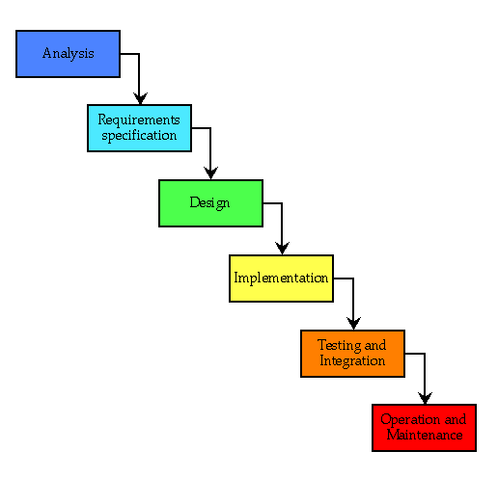

Fig 3.1: Waterfall model

**Requirement Analysis**

This process is also known as feasibility study. In this phase, the development team studied the site requirement. They investigate the need for possible dynamic representation of the site and increase security features. By the end of feasibility study, the team furnishes a document that holds the different specific recommendations for the candidate system. It also includes personnel assignments, costs, project schedules, target dates etc. the requirement gathering process is intensified and focused specially on software. The essential purpose of this phase is to find the need and to define the problem that needs to be solved. During this phase following facts were gathered.

* Determined the user need
* Identified the facts
* Establish the goals and objective for the proposed system
* Feasibility for the new system

**System Analysis and Design**

In this phase the software’s overall structure and its nuances are defined. In terms of client server technology the no of tiers needed for the package architecture, database design, data structure design etc are defined in this phase. Analysis and Design are very crucial in entire development cycle. Any glitch in this phase could be expensive to solve in the later stage of software development. Hence following is the essential approach taken during website designing:

* DFD
* Database Designing
* Form Designing
* Pseudo code for methods

**Testing**

Once the code is generated, the website testing begins. Different testing methodologies are done to unravel the bugs that were committed during the previous phases. Different testing methodologies are used:

* Acceptance testing
* White Box Testing
* Black Box Testing

**3.2 Software Requirement Specification**

**3.2.1 User Requirement**

The following requirements are raised during the analysis of the needs of the users:

* A Person Should be able to login to the system through the first page of the Application.
* The Administrator can create users as per user requirement.
* Admin can upload the data for a particular Student. On successful completion of upload, user (Student/Parent/Faculty) can view reports.
* A general user will have access to see the status of particular Student id number.
* Student (user) can use all the facilities, same as which are provided to him in the college.
* Student can see attendance, marks report and other facilities in updated manner.
* There will be a separate page for every student as his account in which he can get notices, attendance, grades, assignments etc.
* Parent can just view the record of student with the username and password provided.
* Faculty can give the attendances and marks for the students.
* The administrator verifies all these reports and generates them for users to view them.

After analyzing the requirements of the task to be performed, the next step is to analyze the problem and understand its context. The first activity in the phase is studying the existing system and other is to understand the requirements and domain of the new system. Both the activities are equally important, but the first activity serves as a basis of giving the functional specifications and then successful design of the proposed system. Understanding the properties and requirements of a new system is more difficult and requires creative thinking and understanding of existing running system is also difficult, improper understanding of present system can lead diversion from solution.

**Methodology adopted and System implementation**

1. Apache tomcat is used as a web server to host the application.
2. All the environment variables are set.
3. The application is pasted in the webapps folder.
4. Web server is started now.
5. Application is run using the web browser by typing http://localhost/cis
6. Web.xml file is used to control the flow and user actions.

**3.2.2 Software Requirements**

* **Operating System (Server Side):** Windows 7.
* **Operating System (Client Side):** Windows 7.
* **Client End Language:** HTML
* **Local Validation:** PHP
* **Server Side Language:** PHP
* **Database:** My Sql 2000
* **Web Server:** XAMPP server
* **Web Browser:** Internet Explorer 8/ Mozilla Firefox

**3.2.3 Hardware Requirements**

* **Disc Space:** 40 GB
* **PC Used:** IBM Compatible
* **Processor:**  Pentium 3
* **Memory:** 512 MB RAM
* **File System:** 32 Bit

**3.3 XAMPP Installation**

[XAMPP](http://www.apachefriends.org/en/xampp.html) is an easy to install Apache distribution containing MySQL, PHP and Perl. There are packages for [Windows](http://www.apachefriends.org/en/xampp-windows.html), [Mac](http://www.apachefriends.org/en/xampp-macosx.html), and [Linux](http://www.apachefriends.org/en/xampp-linux.html).

This article will walk you through the steps to install XAMPP on your computer.

Note: These are the Windows installation instructions – see the Apache Friends website for the [Mac](http://www.apachefriends.org/en/xampp-macosx.html) and [Linux](http://www.apachefriends.org/en/xampp-linux.html) installation instructions.

1. Download the installer file for the [latest version of XAMPP](http://www.apachefriends.org/en/xampp-windows.html#641), and save the file to your computer.

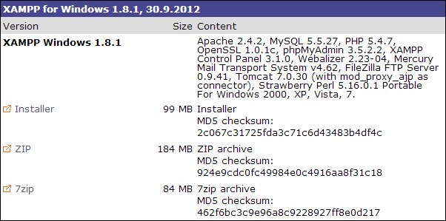

Fig 3.3: XAMPP Welcome Window

1. Next, you need to open the folder where you saved the file, and double-click the installer file.

You will be prompted to select the language you wish to use in XAMPP. **Click the arrow** in the dropdown box, **select your language** in the list, and then **click OK** to continue the installation process.

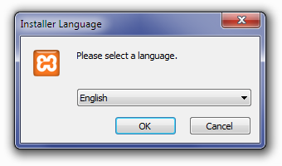

Fig 3.3.1: XAMPP Language Selection

1. For Windows 7 users, you will see a window pop up, warning you about User Account Control (UAC) being active on your system. Click OK to continue the installation.

Next you will see the Welcome to the XAMPP Setup Wizard screen. **Click Next** to continue the installation.

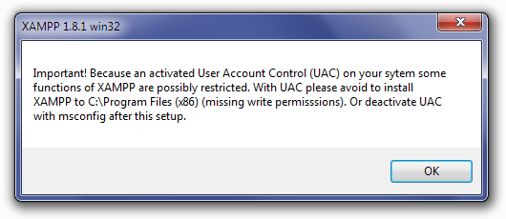

Fig 3.3.2: XAMPP UAC Message

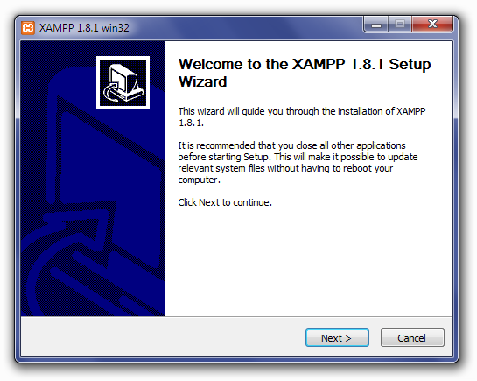

Fig 3.3.3: XAMPP Wizard Starting Window

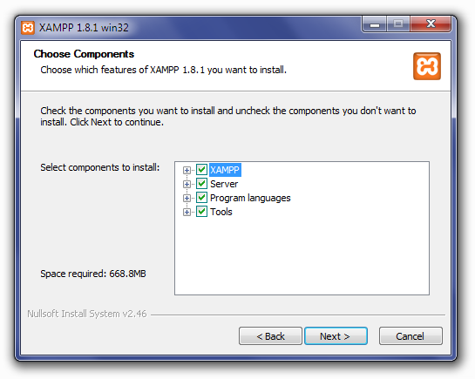

Fig 3.3.4: XAMPP Server Selection Window

1. Next you will see the Choose Install Location screen. Unless you would like to install XAMPP on another drive, you should not need to change anything. **Click Install** to continue.

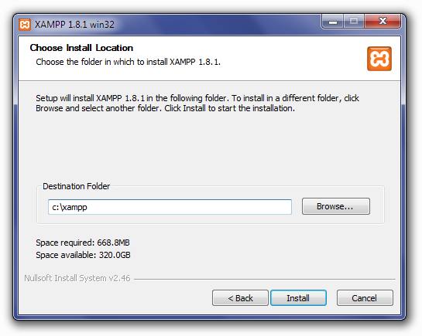

Fig 3.3.5: XAMPP Installation path Window

1. XAMPP will begin extracting files to the location you selected in the previous step.

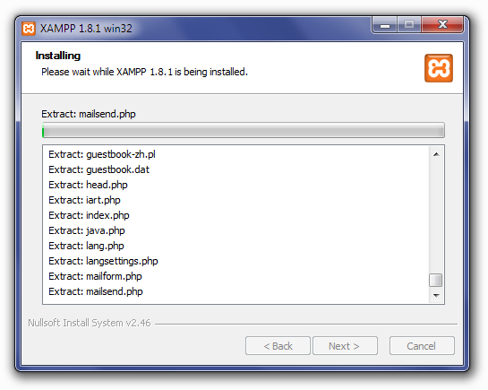

Fig 3.3.6: XAMPP File Extraction

1. Once all of the files have been extracted, the Completing the XAMPP Setup Wizard screen will appear. **Click Finish** to complete the installation.

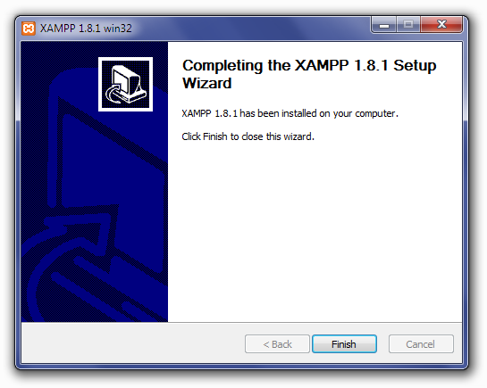Fig 3.3.7: XAMPP Installation Finished Window

1. The Installation Complete screen will now appear. **Click Finish** to begin using XAMPP.

**Fig 5.9: XAMPP Installation Completed Window**

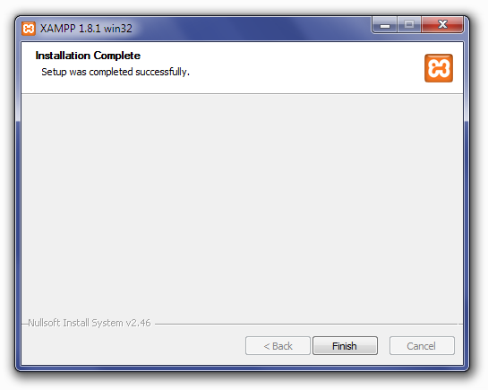

Fig 3.3.8: XAMPP Installation Completed Window

1. After clicking Finish in the previous screen, you will be asked if you want to open the XAMPP Control Panel. **Click Yes**

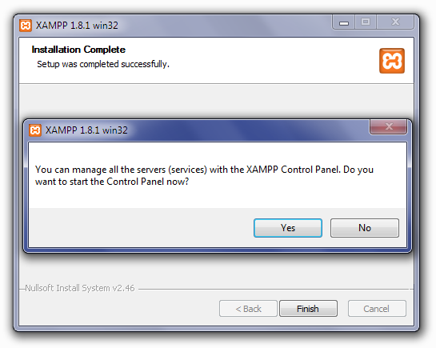

Fig 3.3.9: XAMPP Prompting To Start XAMPP Control Panel

1. The XAMPP Control Panel allows you to manually start and stop Apache and MySQL, or install them as services.

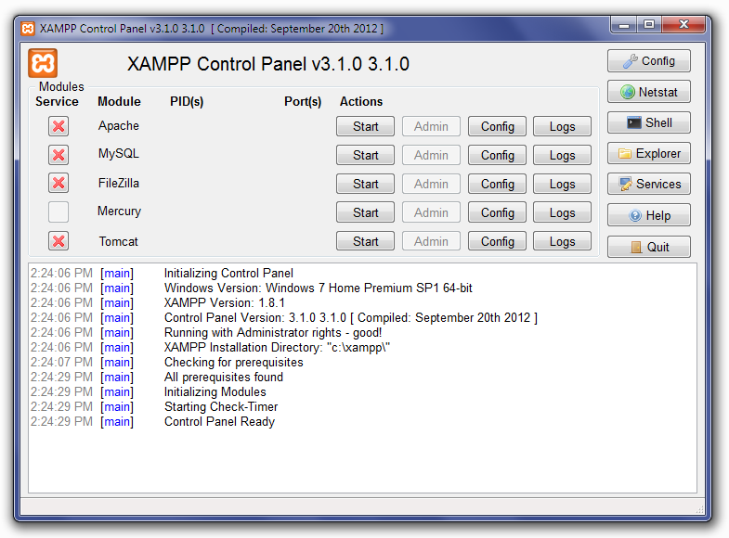

Fig 3.3.10: XAMPP Control Panel

1. To start Apache or MySQL manually, **click the Start button** under **Actions** next to that module.

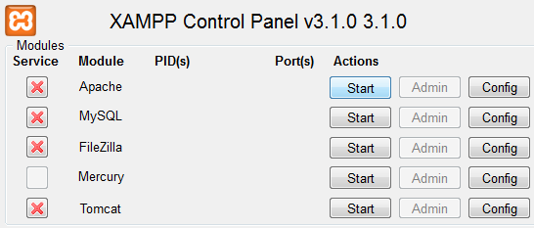

Fig 3.3.11: XAMPP Control Panel with Installed Services

1. Depending on your security settings, Windows 7 users will probably have a small window open, asking if you want to allowxampp-control.exe to make modifications to your computer. Click Yes to allow Apache or MySQL to start.

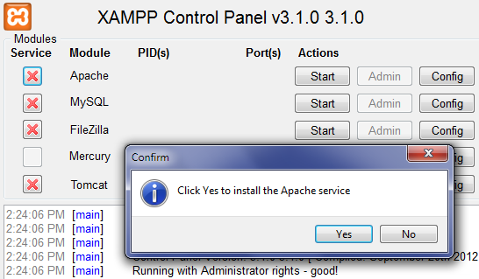

Fig 3.3.12: XAMPP prompting to install Apache Service

1. Once again, you may have a security window open, asking if you want to allow the modifications to your computer. **Click Yes** to allow it.

The **red X** will change to a **green check mark** once the service has been installed successfully.

**3.3 System Planning**

Here we make system planning Perform and evaluate feasibility studies like cost-benefit analysis, technical feasibility, time feasibility and operational feasibility for the project. Project Scheduling should be made using PERT charts.

Feasibility study is carried out decide whether the proposed system is feasible for the company. The feasibility study is to serve as a decision document it must answer three key questions:

1. Is there a new and better way to do the job that will benefit the user?
2. What are the cost and the savings of the alternative(s)?
3. What is recommended?

**Technical feasibility**

Technical feasibility centers on the existing computer system i.e. Hardware, Software etc. Bank requires SQL database management that are all easily available with extensive development support through manuals and blogs.

**Economical feasibility**

Economical Feasibility is the most frequently used method for evaluating the effectiveness of a candidate system. More commonly known as Cost/ Benefit analysis, the procedure is to determine the benefits and savings that are expected from the candidate system and compare them with costs. If the benefits outweigh costs, then the decision is made to design and implement the system.

**3.4 Study of the System**

In the flexibility of the uses the interface has been developed a graphics concept in mind, associated through a browser interface. The GUI’S at the top level have been categorized as

1. Administrative user interface
2. The operational or generic user interface

The administrative user interface concentrates on the consistent information that is practically, part of the organizational activities and which needs proper authentication for the data collection. The interfaces help the administrations with all the transactional states like Data insertion, Data deletion and Date updation along with the extensive data search capabilities.

The operational or generic user interface helps the users upon the system in transactions through the existing data and required services. The operational user interface also helps the ordinary users in managing their own information helps the ordinary users in managing their own information in a customized manner as per the assisted flexibilities.

The system after careful analysis has been identified to be presented with the following modules:

The modules involved are:

1. Student attendance status: It gives the attendance status of students. Faculty will update the attendance periodically and can be seen by students and parents.
2. Student’s performance in exams: This faculty provides the performance of the student in each exam which is conducted by university or college such as midterm performance. Marks obtained by students in exams will be updated by faculties that can be access by students and parents.
3. Information about staff: It will help in maintaining complete information about college faculty members such as their department, cadre, date of joining, salary, etc. Administrator will register new faculties and remove their account when they leave the college.

**3.5 Content Diagram**

This document play a vital role in the development of life cycle (SDLC) as it describes the complete requirement of the system. It means for use by developers and will be the basic during testing phase. Any changes made to the requirements in the future will have to go through formal change approval process.

**SPIRAL MODEL** was defined by Barry Boehm in his 1988 article, “A spiral Model of Software Development and Enhancement. This model was not the first model to discuss iterative development, but it was the first model to explain why the iteration models.

As originally envisioned, the iterations were typically 6 months to 2 years long. Each phase starts with a design goal and ends with a client reviewing the progress thus far. Analysis and engineering efforts are applied at each phase of the project, with an eye toward the end goal of the project.

The steps for Spiral Model can be generalized as follows:

* The new system requirements are defined in as much details as possible. This usually involves interviewing a number of users representing all the external or internal users and other aspects of the existing system.
* A preliminary design is created for the new system.
* A first prototype of the new system is constructed from the preliminary design. This is usually a scaled-down system, and represents an approximation of the characteristics of the final product.
* A second prototype is evolved by a fourfold procedure:

1. Evaluating the first prototype in terms of its strengths, weakness, and risks.
2. Defining the requirements of the second prototype.
3. Planning and designing the second prototype.
4. Constructing and testing the second prototype.

* At the customer option, the entire project can be aborted if the risk is deemed too great. Risk factors might involved development cost overruns, operating-cost miscalculation, or any other factor that could, in the customer’s judgment, result in a less-than-satisfactory final product.
* The existing prototype is evaluated in the same manner as was the previous prototype, and if necessary, another prototype is developed from it according to the fourfold procedure outlined above.
* The preceding steps are iterated until the customer is satisfied that the refined prototype represents the final product desired.
* The final system is constructed, based on the refined prototype.
* The final system is thoroughly evaluated and tested. Routine maintenance is carried on a continuing basis to prevent large scale failures and to minimize down time.

The following diagram shows how a spiral model acts like:

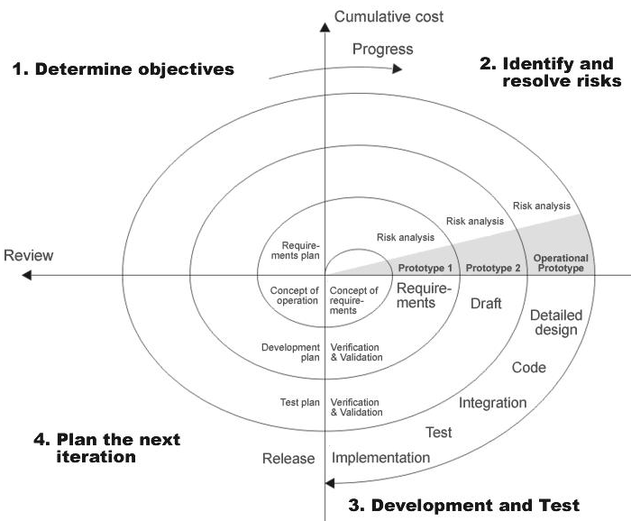

Fig 3.5: Spiral model

**3.6 Conclusion**

Our web application is developed using the above software and hardware requirements using the XAMPP server.

**Chapter–4**

**Design**

4.1 Introduction

The unified modeling language allows the software engineer to express an analysis model using the modeling notation that is governed by a set of syntactic semantic and pragmatic rules. A UML system is represented using five different views that describe the system from distinctly different perspective.

UML is specifically constructed through two different domains they are:

* UML Analysis modeling, this focuses on the user model and structural model views of the system.
* UML design modeling, which focuses on the behavioral modeling, implementation modeling and environmental model views.

**Why Use UML in projects?**

As the strategic value of software increases for many companies, the industry looks for techniques to automate the production of software and to improve quality and reduce cost and time-to-market. These techniques include component technology, visual programming, patterns and frameworks. Businesses also seek techniques to manage the complexity of systems as they increase in scope and scale. In particular, they recognize the need to solve recurring architectural problems, such as physical distribution, concurrency, replication, security, load balancing and fault tolerance. Additionally, the development for the World Wide Web, while making some things simpler, has exacerbated these architectural problems. The Unified Modeling Language (UML) was designed to respond to these needs.

Simply, Systems design refers to the process of defining the architecture, components, modules, interfaces, and data for a system to satisfy specified requirements which can be done easily through UML diagrams.

In this project four basic UML diagrams have been explained

1. Class Diagram
2. Use Case Diagram
3. Sequence Diagram
4. Activity Diagram
5. Collaboration Diagram
6. Deployment Diagram
7. State Chart Diagram
8. Component Diagram

**Class Diagram**

In software engineering, a class diagram in the Unified Modeling Language (UML) is a type of static structure diagram that describes the structure of a system by showing the system's classes, their attributes, and the relationships between the classes.

This is one of the most important of the diagrams in development. The diagram breaks the class into three layers. One has the name, the second describes its attributes and the third its methods. A padlock to left of the name represents the private attributes. The relationships are drawn between the classes. Developers use the Class Diagram to develop the classes. Analyses use it to show the details of the system.

Architects look at class diagrams to see if any class has too many functions and see if they are required to be split.

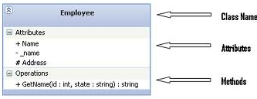

**Use Case Diagram**

In software engineering, a use case diagram in the Unified Modeling Language (UML) is a type of behavioral diagram defined by and created from a Use-case analysis. Its purpose is to present a graphical overview of the functionality provided by a system in terms of actors, their goals (represented as use cases), and any dependencies between those use cases. The main purpose of a use case diagram is to show what system functions are performed for which actor. Roles of the actors in the system can be depicted. Use cases are used during requirements elicitation and analysis to represent the functionality of the system. Use cases focus on the behavior of the system from the external point of view. The actors are outside the boundary of the system, whereas the use cases are inside the boundary of the system

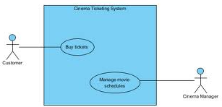

**Sequence Diagram**

A sequence diagram in Unified Modeling Language (UML) is a kind of interaction diagram that shows how processes operate with one another and in what order. It is a construct of a Message Sequence Chart. Sequence diagrams are sometimes called Event-trace diagrams, event scenarios, and timing diagrams

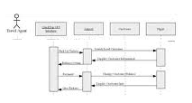

**Activity Diagram**

Activity diagrams are a loosely defined diagram technique for showing workflows of stepwise activities and actions, with support for choice, iteration and concurrency. In the Unified Modeling Language, activity diagrams can be used to describe the business and operational step-by-step workflows of components in a system. An activity diagram shows the ove rall flow of control.

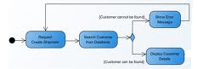

**Collaboration Diagram**

A Communication diagram models the interactions between objects or parts in terms of sequenced messages. Communication diagrams represent a combination of information taken from Class, Sequence, and Use Case Diagrams describing both the static structure and dynamic behavior of a system.

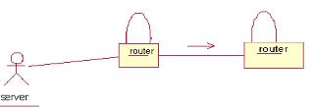

**Deployment Diagram**

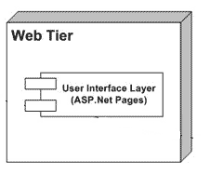A deployment diagram in the Unified Modeling Language models the physical deployment of artifacts on nodes. To describe a web site, for example, a deployment diagram would show what hardware components ("nodes") exist (e.g., a web server, an application server, and a database server), what software components ("artifacts") run on each node (e.g., web application, database), and how the different pieces are connected (e.g. JDBC, REST, RMI).

**State Chart Diagram**

A state diagram is a type of diagram used in computer science and related fields to describe the behavior of systems. State diagrams require that the system described is composed of a finite number of states; sometimes, this is indeed the case, while at other times this is a reasonable abstraction. Many forms of state diagrams exist, which differ slightly and have different semantics.

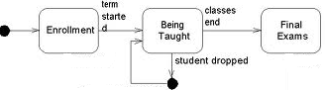

**Component Diagram**

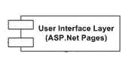 In the Unified Modeling Language, a component diagram depicts how components are wired together to form larger components and or software systems. They are used to illustrate the structure of arbitrarily complex systems.

**4.2 UML/ER/DFD Diagrams**

**4.2.1 UML Diagrams**

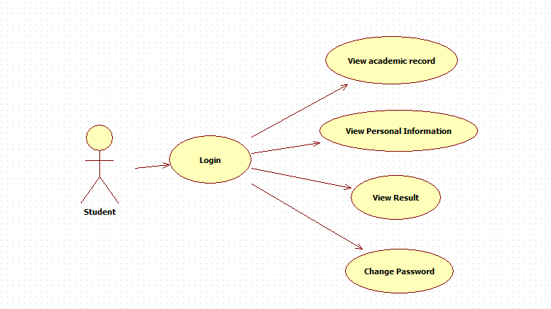

Fig 4.2: Student Usecase Diagram

**Component Diagram:**

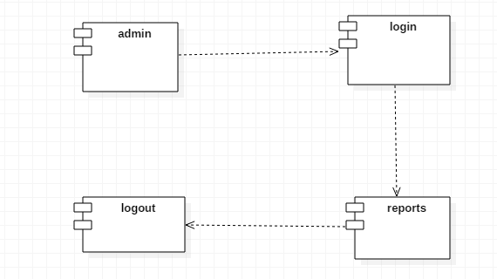

Fig 4.2.1: Component Diagram

**Sequence Diagram:**

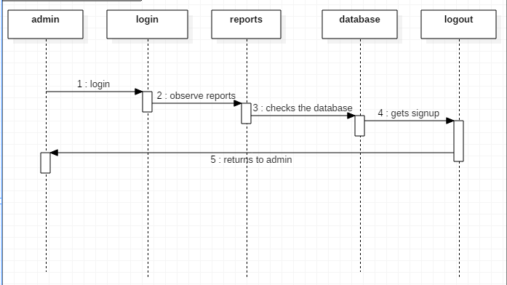

Fig 4.2.2: Sequence Diagram

**4.2.2** **Data-Flow Diagrams**

**Admin Details Data Flow**

ID

Login

Fig 4.2.3: Admin dataflow diagram

**Student Details Data Flow**

ID

Login

Fig 4.2.4: Student dataflow diagram

**Parent Details Dataflow**

ID

Login

Fig 4.2.5: Parent dataflow diagram

**4.2.3 ER Diagram**

ER Diagram for this Student Information System is:

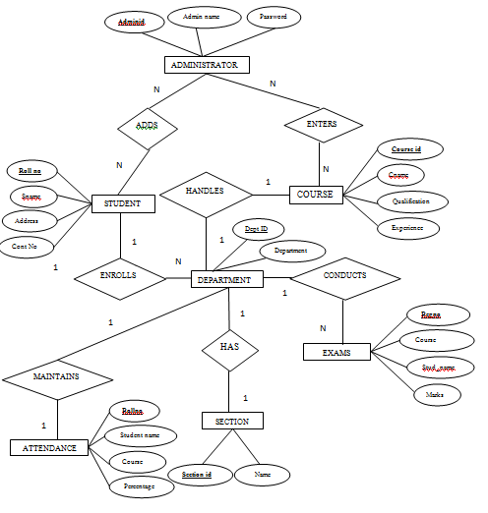

Fig 4.2.6: ER Diagram

**4.3 Conclusion**

The model that is used for developing our web application is spiral model which contain several levels and each level has same sequence of steps.

**Chapter-5**

**IMPLEMENTATION & RESULTS**

**5.1 Introduction**

The student information system flourishes with the rapid development of computer technology and. Student information system is not only a large of information processing, information processing in a timely manner to facilitate the preservation and many other advantages, but also has high reliability and security. Therefore, various colleges are s2eeking to develop their own student information system to enhance their quality and efficiency.

* 1. **Technology used**

**5.2.1 PHP (Preprocessor Hypertext)**

PHP is a server-side scripting language designed for web development but also used as a general-purpose programming language**.** Originally created by Rasmus Lerdorf in 1995, the reference implementation of PHP is now produced by The PHP Group. While PHP originally stood for Personal Home Page, it now stands for PHP: Hypertext Preprocessor, a recursive acronym.

PHP code is interpreted by a web server with a PHP processor module, which generates the resulting web page: PHP commands can be embedded directly into an HTML source document rather than calling an external file to process data. It has also evolved to include a command-line interface capability and can be used in standalone graphical applications.

PHP is free software released under the PHP License. PHP can be deployed on most web servers and also as a standalone shell on almost every operating system and platform, free of charge.

**History of PHP**

PHP development began in 1994 when the developer Rasmus Lerdorf wrote a series of Common Gateway Interface (CGI) Perl scripts, which he used to maintain his personal homepage. Zeev Suraski and Andi Gutmans rewrote the parser in 1997 and formed the base of PHP 3,changing the language's name to the recursive acronym PHP: Hypertext Preprocessor. Afterwards, public testing of PHP 3 began, and the official launch came in June 1998. Suraski and Gutmans then started a new rewrite of PHP's core, producing the Zend Engine in 1999. They also founded Zend Technologies in Ramat Gan, Israel.On May 22, 2000, PHP 4, powered by the Zend Engine 1.0, was released. As of August 2008 this branch reached version 4.4.9. PHP 4 is no longer under development nor will any security updates be released.

On July 13, 2004, PHP 5 was released, powered by the new Zend Engine II. PHP 5 included new features such as improved support for object-oriented programming, the PHP Data Objects (PDO) extension (which defines a lightweight and consistent interface for accessing databases), and numerous performance enhancements. In 2008 PHP 5 became the only stable version under development. Late static binding had been missing from PHP and was added in version 5.3.

A new major version has been under development alongside PHP 5 for several years. This version was originally planned to be released as PHP 6 as a result of its significant changes, which included plans for full Unicode support. However, Unicode support took developers much longer to implement than originally thought and the decision was made in March 2010 to move the mini project to a branch, with features still under development moved to trunk. Changes in the new code include the removal of register_globals, magic quotes, and safe mode. The reason for the removals was that register_globals had opened security holes by intentionally allowing runtime data injection, and the use of magic quotes had an unpredictable nature. Instead, to escape characters, magic quotes may be replaced with the addslashes() function, or more appropriately an escape mechanism specific to the database vendor itself like mysql_real_escape_string () for MySQL.

**Functioning and Implementation**

The PHP interpreter only executes PHP code within its delimiters. Anything outside its delimiters is not processed by PHP (although non-PHP text is still subject to control structures described in PHP code). The most common delimiters are <?php to open and ?> to close PHP sections. <script language=”php”> and </script> delimiters are also available, as are the shortened forms <? or <?= (which is used to echo back a string or variable) and ?> as well as ASP-style short forms <% or <%= and %>. While short delimiters are used, they make script files less portable as support for them can be disabled in the PHP configuration, and they are therefore discouraged. The purpose of all these delimiters is to separate PHP code from non-PHP code, including HTML.

The first form of delimiters, <?php and ?>, in XHTML and other XML documents, creates correctly formed XML "processing instructions". This means that the resulting mixture of PHP code and other markup in the server-side file is itself well-formed XML.

Variables are prefixed with a dollar symbol, and a type does not need to be specified in advance. Unlike function and class names, variable names are case sensitive. Both double-quoted (“”) and here strings provide the ability to interpolate a variable's value into the string. PHP treats newlines as whitespace in the manner of a free-form language (except when inside string quotes), and statements are terminated by a semicolon. PHP has three types of comment syntax: /* */ marks block and inline comments: // as well as # are used for one-line comments. The echo statement is one of several facilities PHP provides to output text, e.g., to a web browser. Rules for PHP variables are generally: A variable starts with the $ sign, followed by the name of the variable. A variable name must start with a letter or the underscore character. A variable name cannot start with a number. A variable name can only contain alpha-numeric characters and underscores (A-z, 0-9, and _). Variable names are case sensitive ($y and $Y are two different variables).

Super globals were introduced in PHP 4.1.0, and are built-in variables that are always available in all scopes. Several predefined variables in PHP are "super globals", which means that they are always accessible, regardless of scope - and you can access them from any function, class or file without having to do anything special. The PHP super global variables are:

$_GLOBALS - The global keyword is used to access a global variable from within a function. PHP also stores all global variables in an array called $GLOBALS[index]. The index holds the name of the variable. This array is also accessible from within functions and can be used to update global variables directly.

$_SERVER - is a PHP super global variable which holds information about headers, paths, and script locations.

$_REQUEST - is used to collect data after submitting an HTML form.

$_POST - is widely used to collect form data after submitting an HTML form with method="post". $_POST is also widely used to pass variables. Information sent from a form with the POST method is **invisible to others** (all names/values are embedded within the body of the HTTP request) and has **no limits** on the amount of information to send.

$_GET - can also be used to collect form data after submitting an HTML form with method="get". $_GET can also collect data sent in the URL. Information sent from a form with the GET method is **visible to everyone** (all variable names and values are displayed in the URL). GET also has limits on the amount of information to send.

$_FILES - An associative array of items uploaded to the current script via the HTTP POST method.

$_ENV - These variables are imported into PHP's global namespace from the environment under which the PHP parser is running. Other environment variables include the CGI variables, placed there regardless of whether PHP is running as a server module or CGI processor.

$_COOKIE - It is often used to identify a user. This is stored on the user’s computer so that every user will be identified if who are they. You can create and get the value of a cookie. setCookie() function is the function used to create a cookie.

**Objects**

Basic object-oriented programming functionality was added in PHP 3. Object handling was completely rewritten for PHP 5, expanding the feature set and enhancing performance. In previous versions of PHP, objects were handled like primitive types. The drawback of this method was that the whole object was copied when a variable was assigned or passed as a parameter to a method. In the new approach, objects are referenced by handle, and not by value. PHP 5 introduced private and protected member variables and methods, along with abstract classes and final classes as well as abstract methods and final methods. It also introduced a standard way of declaring constructors and destructors, similar to that of other object-oriented languages such as C++, and a standard exception handling model.

If the developer creates a copy of an object using the reserved word *clone*, the Zend engine will check if a __clone() method has been defined or not. If not, it will call a default__clone() which will copy the object’s properties. If a __clone () method is defined, then it will be responsible for setting the necessary properties in the created object. For convenience, the engine will supply a function that imports the properties of the source object, so that the programmer can start with a by-value replica of the source object and only override properties that need to be changed.

**Advantages of PHP**

1. **Open Source -** PHP is freely available for use. The community of open source PHP developers provides technical support and is constantly improving updating the core PHP functionalities. PHP is available at free of cost under PHP General Public License and most of its associative required software's like MySQL, Text Editors and Apache Server are also freely available, so it proves very cost effective for the developers.
2. **Cross-Platform -** PHP provides high compatibility with leading operating systems and web servers such as thereby enabling it to be easily deployed across several different platforms. PHP scripts can run across operating systems such as Linux, Windows, Solaris, OpenBSD, Mac OSX etc. and also provide support for all major web servers such as Apache, IIS, iPlanet etc
3. **Power -** Several web tasks can now be easily performed using PHP. For example now we can develop from small websites to giant business and organizational websites, informative forums, chatting platforms, CRM solutions, e-commerce shopping, community websites, e-business and gigantic database driven sites.
4. **User Friendly -** Designed in a user friendly manner, PHP gives more flexibility than C, C++ and ASP and overall helps in increasing traffic to the site.
5. **Object Oriented -** PHP actually has the ability to call Java and Windows COM objects. In addition to this, you can create custom classes. Other classes can actually borrow from those custom classes as well which extends the capabilities of PHP even further.
6. **Quick -** PHP is designed to work well with the web, and so things like accessing the GET and POST and working with HTML and URLs are built-ins in the PHP language. This makes it really concise and straightforward to make a website.
7. **Extensions -** Being an open source language, a large number of libraries and extensions, to extend its core functionalities, are available for download. The source code of PHP can be modified to include custom created extensions and components thereby increasing its extensibility.
8. **Scalability -** In the world of IT, the word scalability is like gold. Whether you’re dealing with databases, hosting, or in this case, programming, scalability is never a bad thing. Due to the way PHP is built, you can easily increase your cluster size by adding more servers as your mini projects grow. There are many hosting companies that will, for a few dollars a month, give you a server running PHP so you can make a website really easily.
9. **Automatically Refreshes -** Nowadays developing dynamic websites are in the huge demand due to its specific characteristics like it automatically refreshes and does not need to make many changes manually.
10. **Community Support -** A huge advantage that PHP offers is its community. If you are looking for a particular script, chances are another user has already created something similar. Check within the PHP community for availability. Likewise, if you have created a function that others might enjoy, be sure to post the code for others.
11. **Easier to fix problems -** When it comes to web application development, you’re bound to run into issues and come across the occasional “fail”. But the benefit you get with PHP is that problems aren’t as difficult to find and fix as they are with other languages. This is because with each request, PHP cleans up and starts over. So an issue with one request will not necessarily disrupt another.
12. **Security -** PHP offers security as well that helps prevent malicious attacks. These security levels can be adjusted in the .ini file.
13. **Sessions -** PHP provides extensive session and cookie management features and functions enabling the creation and development of personalized web pages.
14. **Graphics -** PHP can be used to generate images and graphics dynamically. Using the image functionalities available with PHP, the header information of images can be accessed and manipulated. The library of PHP includes a host of features and functionalities that can be used to create images in various formats, such as gif, jpeg and png.

**Requirements for PHP**

* You need PHP 5.2.0 or newer, with session support and the Standard PHP Library (SPL) extension.To support uploading of ZIP files, you need the PHP zip extension.
* For proper support of multibyte strings (eg. UTF-8, which is currently default), you should install mbstring and ctype extensions.
* You need GD2 support in PHP to display inline thumbnails of JPEGs (“image/jpeg: inline”) with their original aspect ratio
* When using the “cookie” authentication method, the mcrypt extension is strongly suggested
* For most users and is required for 64–bit machines. Not using mcrypt will cause phpMyAdmin to load pages significantly slower.
  + 1. **MySQL**

MySQL is the world's second most widely used open-source relational database management system. MySQL is named after co-founder Monty Widenius's daughter: My. MySQL is a popular choice of database for use in web applications, and is a central component of the widely used LAMP open source web application software stack. Free-software-open source mini projects that require a full-featured database management system often use MySQL. MySQL is also used in many high-profile, large-scale websites, including Wikipedia, Google.

MySQL is a relational database management system, and ships with no GUI tools to administer MySQL databases or manage data contained within the databases. Users may use the included command line tools, or use MySQL "front-ends", desktop software and web applications that create and manage MySQL databases, build database structures, back up data, inspect status, and work with data records. The official set of MySQL front-end tools, MySQL Workbench is actively developed by Oracle, and is freely available for use.

Users may use the included command line tools, or use MySQL "front-ends", desktop software and web applications that create and manage MySQL databases, build database structures, back up data, inspect status, and work with data record. The official set of MySQL front-end tools, MySQL Workbench is actively developed by Oracle, and is freely available for use. phpMyAdmin is a free Web-based front end widely installedby web hosts, since it is developed in PHP and is included in the LAMP stack, MAMP, XAMPP and WAMP software bundle installers.

**Database Tables -** A database most often contains one or more tables. Each table is identified by a name (e.g. “Customers” or “Orders”). Tables contain records (rows) with data.

**Queries -** A query is a question or a request. With MySQL, we can query a database for specific information and have a record set returned.

**Create a connection to a database -**Before accessing data from a database, we must open a connection to the MySQL server.

In PHP, this is done with the mysql_connect() function. The syntax is

mysql_connect(server-name, username, password);

|  |  |
| --- | --- |
| **Parameter** | **Description** |
| *Server-name* | Optional. Specifies the server to connect to Default value is “localhost:3306”. |
| *Username* | Optional. Specifies the username to log in and the default value is the name of the user that owns the server process. |
| *Password* | Optional. Specifies the password to log in with Default is “”. |

There are more available parameters, but these are the most important. The connection will be closed automatically when the script ends.

**Closing a Connection -** To close the connection before, we can use the mysql_close() function. The connection will also be closed automatically when the script ends.

**Create a Database -** The ‘create database’ statement is used to create a database in MySQL. To get PHP to execute the statement above we must use the mysql_query () function. This function is used to send a query or command to a MySQL connection.

CREATE DATABASE database_name

**Create a Table**

The CREATE TABLE statement is used to create a table in MySQL

**Syntax**

CREATE TABLE table_name

(

column_name1 data_type,

column_name2 data_type,

)

**MySQL Functions**

mysql_affected_rows — get number of affected rows in previous MySQL operation

mysql_change_user — Change logged in user of the active connection

mysql_client_encoding — Returns the name of the character set

mysql_close — Close MySQL connection

mysql_connect — Open a connection to a MySQL Server

mysql_create_db — Create a MySQL database

mysql_data_seek — Move internal result pointer

mysql_db_name — Get result data

mysql_db_query — Send a MySQL query

mysql_drop_db — Drop (delete) a MySQL database

mysql_errno — Returns the numerical value of the error message from previous MySQL operation

mysql_error — Returns the text of the error message from previous MySQL operation

mysql_escape_string — escapes a string for use in a mysql_query

mysql_fetch_array — Fetch a result row as an associative array, a numeric array, or both

mysql_fetch_assoc — Fetch a result row as an associative array

mysql_fetch_field — Get column information from a result and return as an object

mysql_fetch_lengths — get the length of each output in a result

mysql_fetch_object — Fetch a result row as an object

mysql_pconnect — Open a persistent connection to a MySQL server

mysql_ping — Ping a server connection or reconnect if there is no connection

mysql_query — Send a MySQL querymysql_result — Get result data

mysql_select_db — Select a MySQL database

mysql_set_charset — sets the client character set

mysql_stat — Get current system status

mysql_tablename — Get table name of field

mysql_thread_id — Return the current thread ID

mysql_unbuffered_query — Send an SQL query to MySQL, without fetching and buffering the result.

**5.2.3 PHPMyAdmin**

PHPMyAdminis an open source tool written in PHP intended to handle the administration of MySQL over the World Wide Web. PHPMyAdmin supports a wide range of operations with MySQL. Currently it can create and drop databases, create/drop/alter tables, delete /edit/add fields, execute any SQL statement, manage users and permissions, and manage keys on fields. While you still have the ability to directly execute any SQLstatement. PhpMyAdmin can manage a whole MySQL server (needs a super-user) as well as a single database.

PhpMyAdmin can:

* Browse and drop databases, tables, views, fields and indexes.
* Create copy, drop, rename and alter databases, tables, fields and indexes.
* Maintenance server, databases and tables, with proposals on server configuration.
* Execute, edit and bookmark any SQL-statement, even batch-queries.
* Load text files into tables.
* Create and read dumps of tables.
* Administer multiple servers and manage MySQL users and privileges.
  1. **Input and Output Screen Design (Screens)**

1. **Home page**

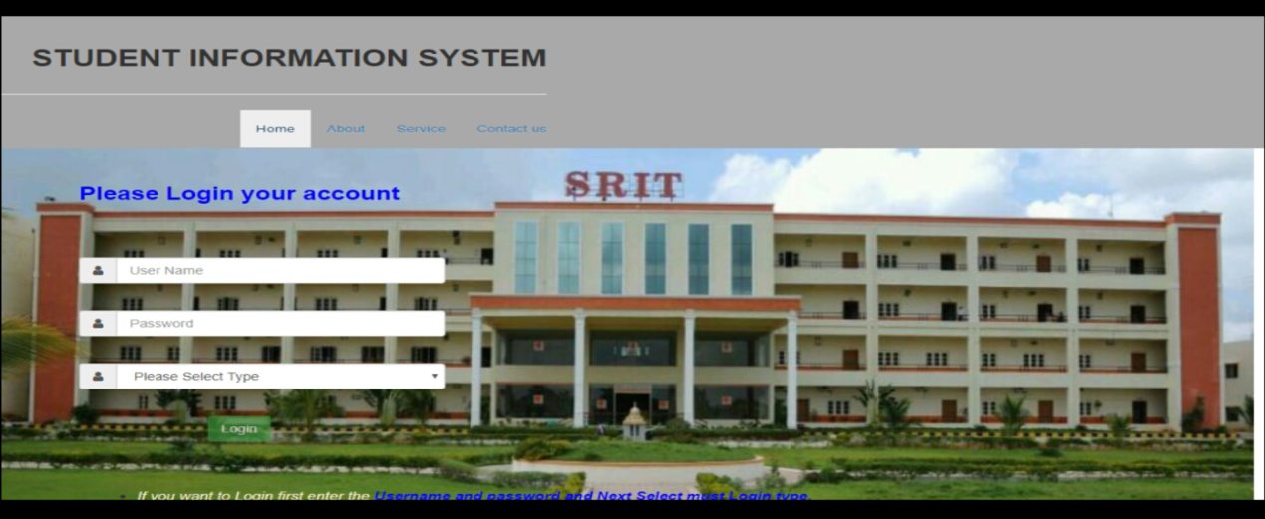

1. **Information page**

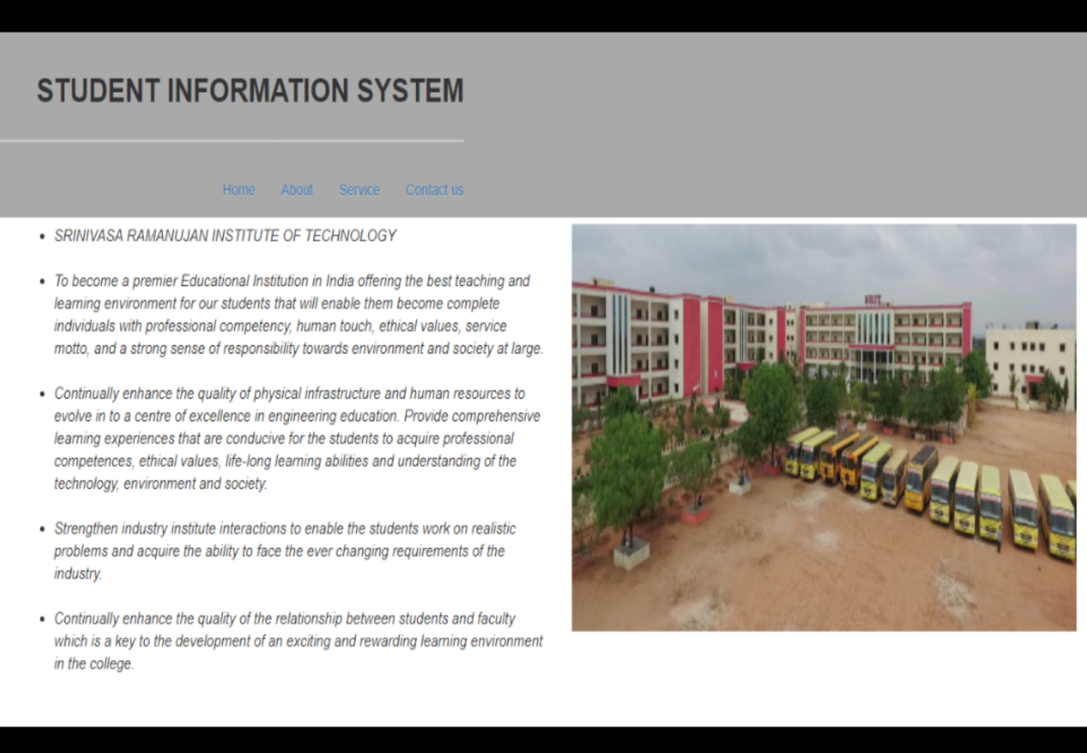

1. **Service page**

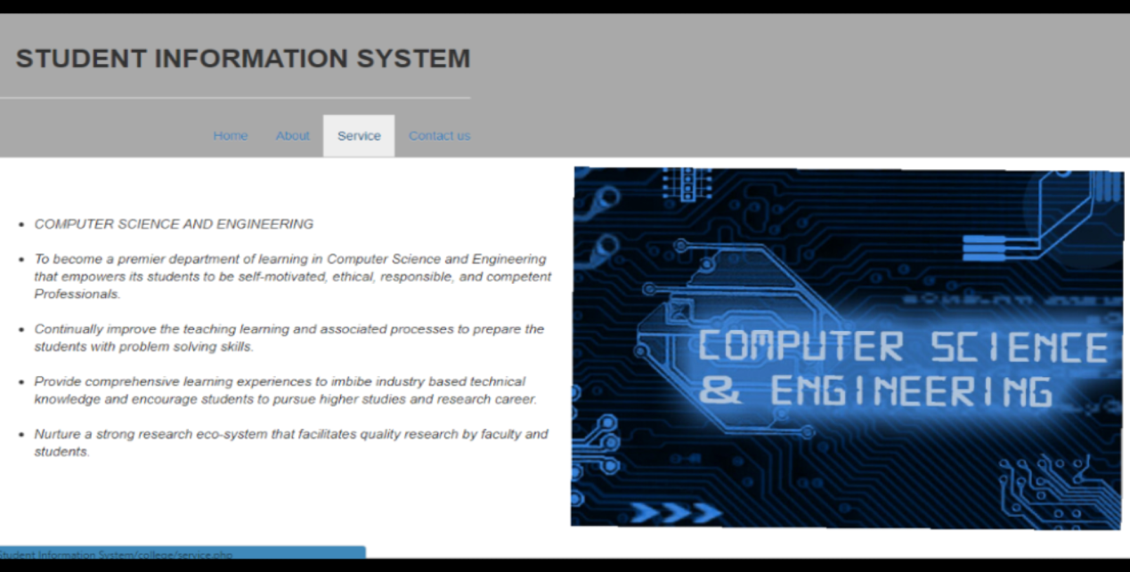

1. **Contact page**

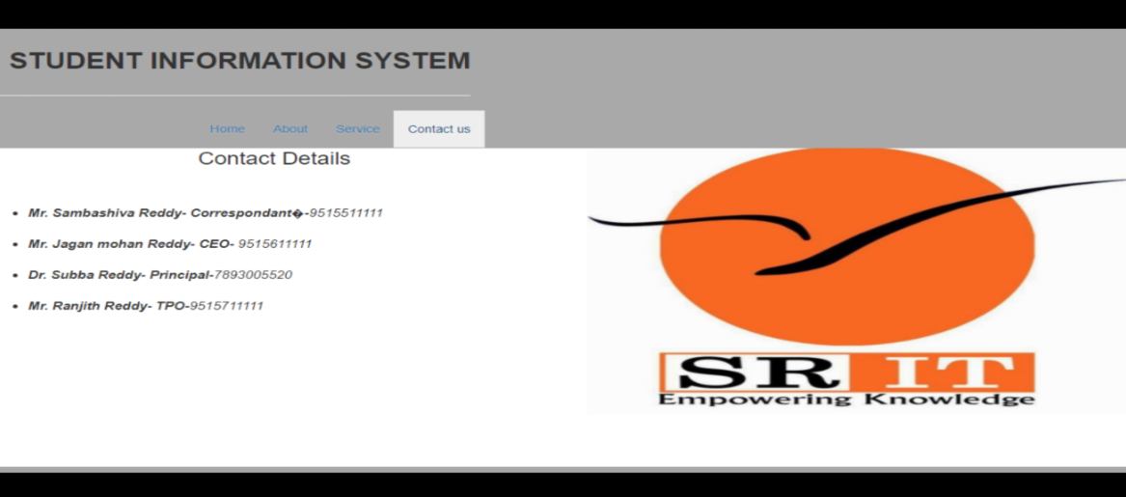

1. **Student login page**

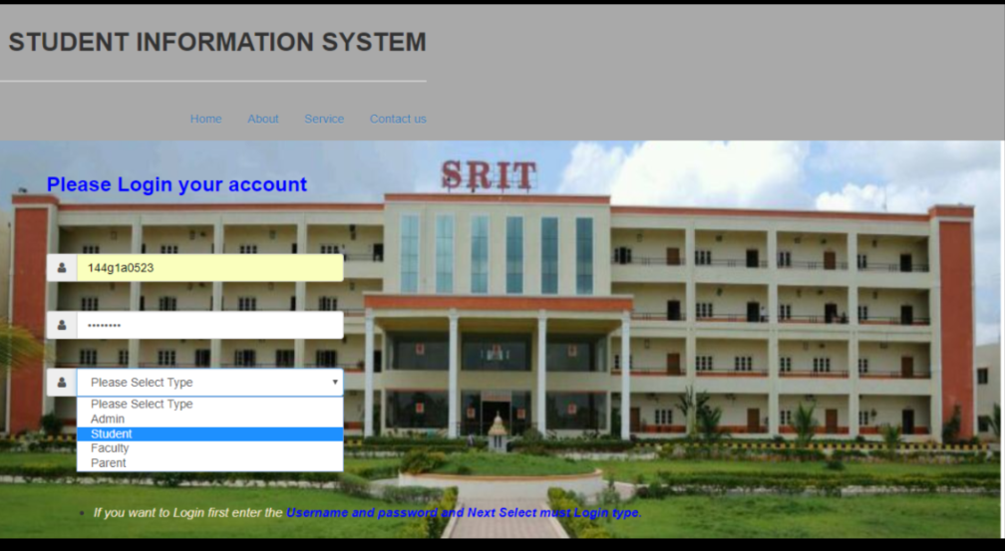

1. **Student home page**

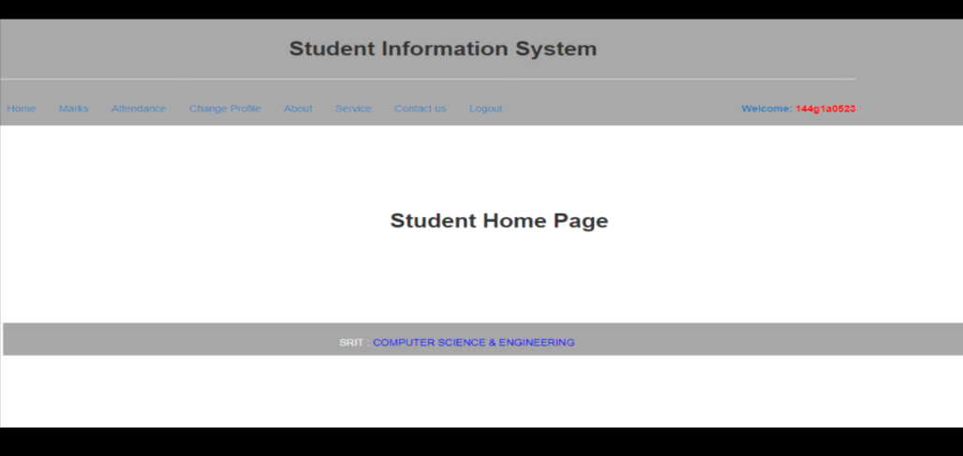

1. **Viewing student marks for student**

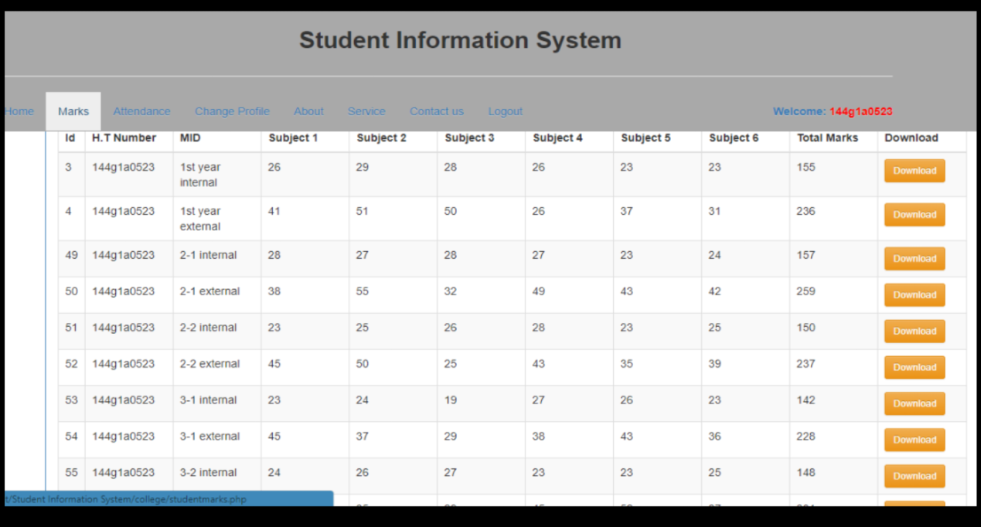

1. **Viewing Student attendance for student**

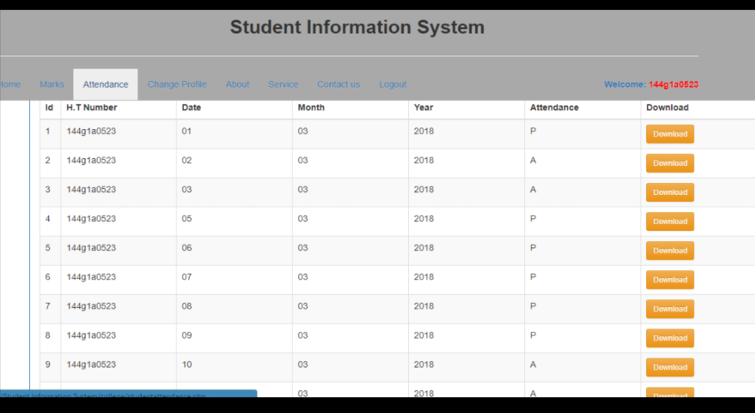

1. **Changing profile page for student**

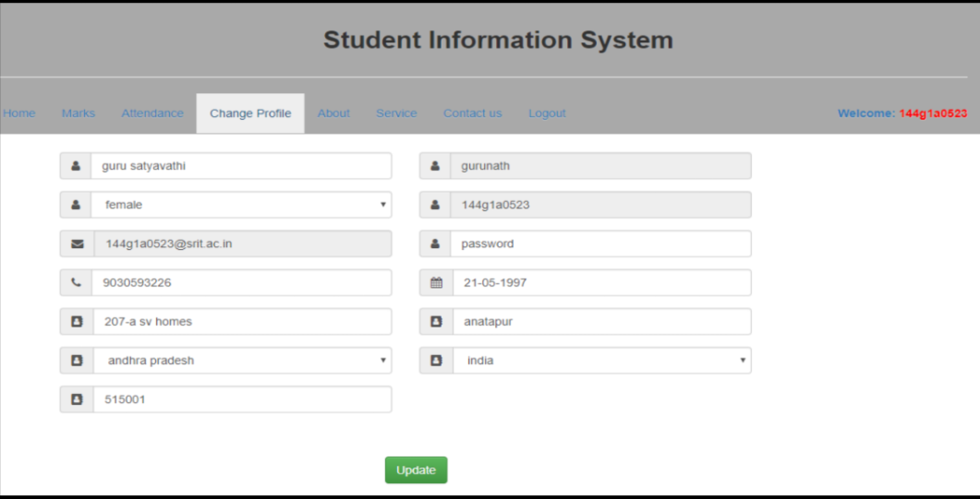

1. **Admin login page**

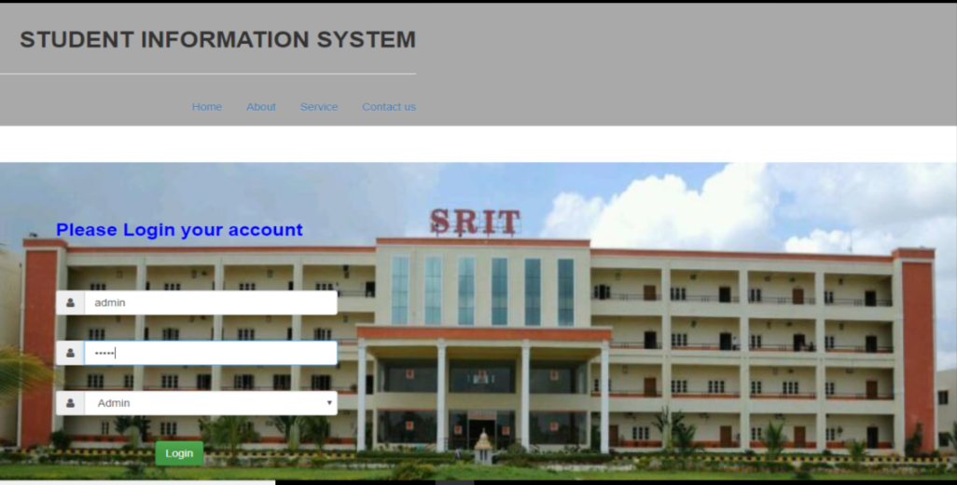

**11) Admin login page**

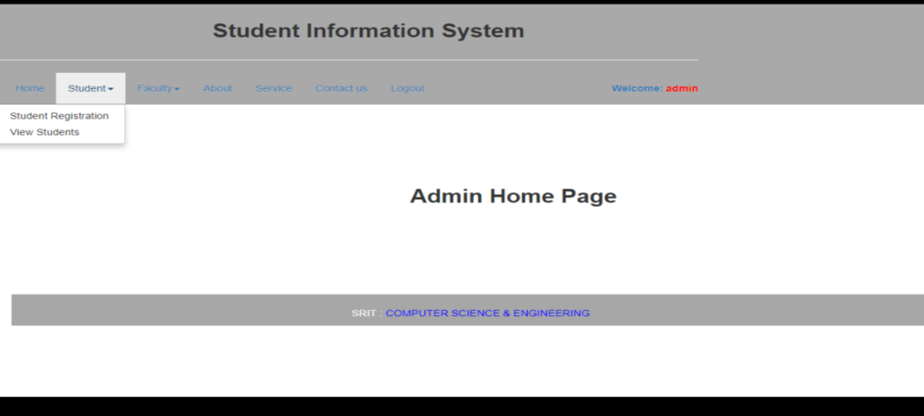

**12) Viewing students information**

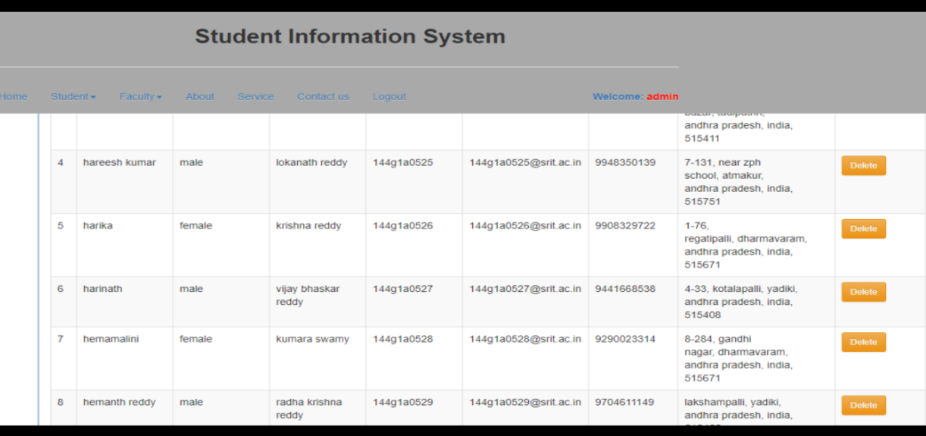

**13) Student registration page**

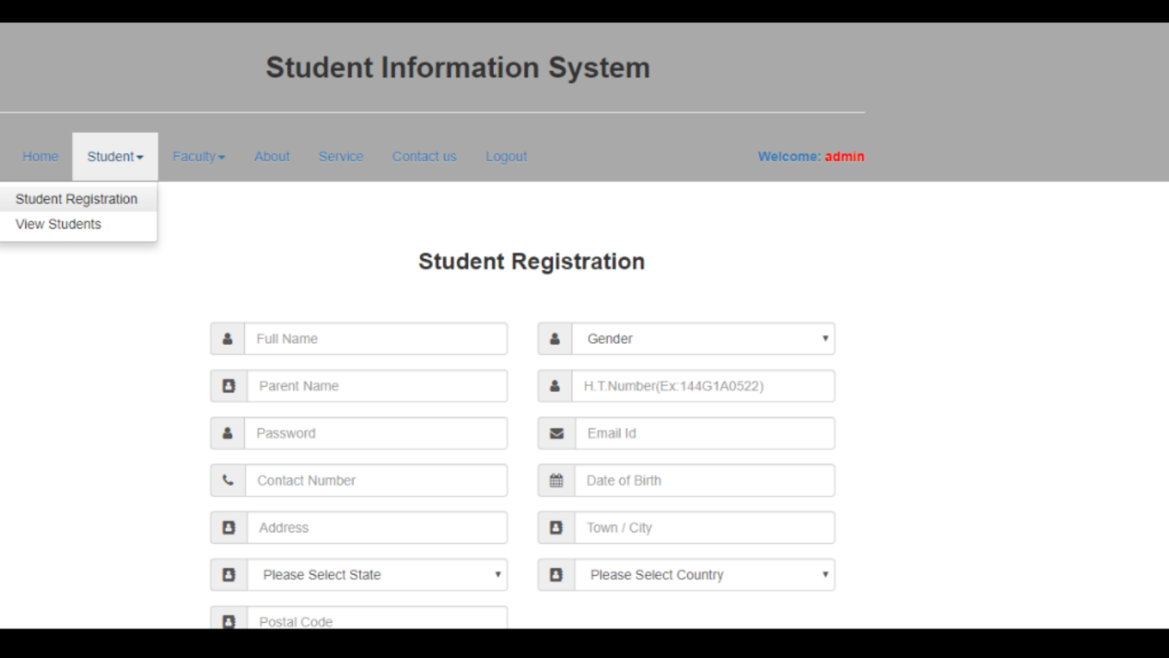

**14) Viewing faculty information**

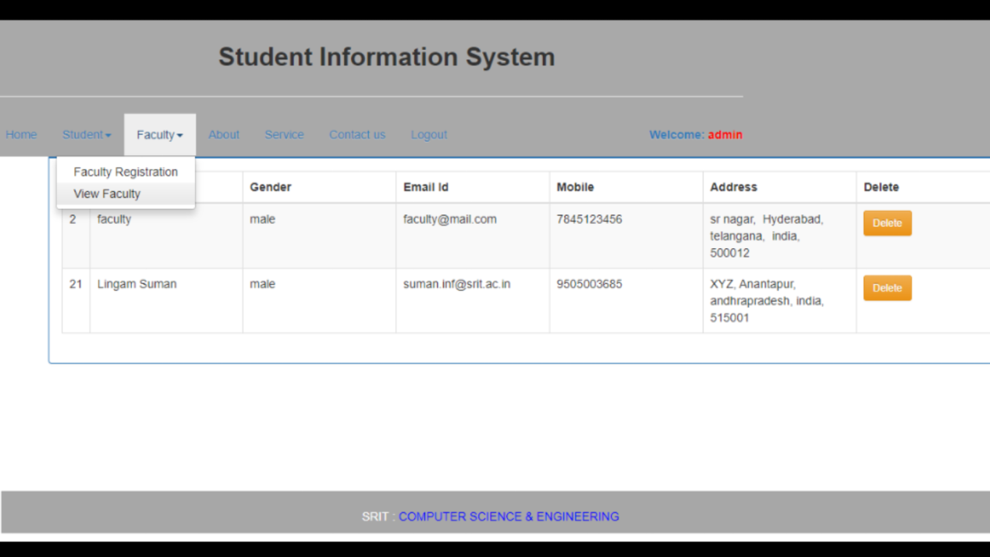

**15) Registration page for faculty**

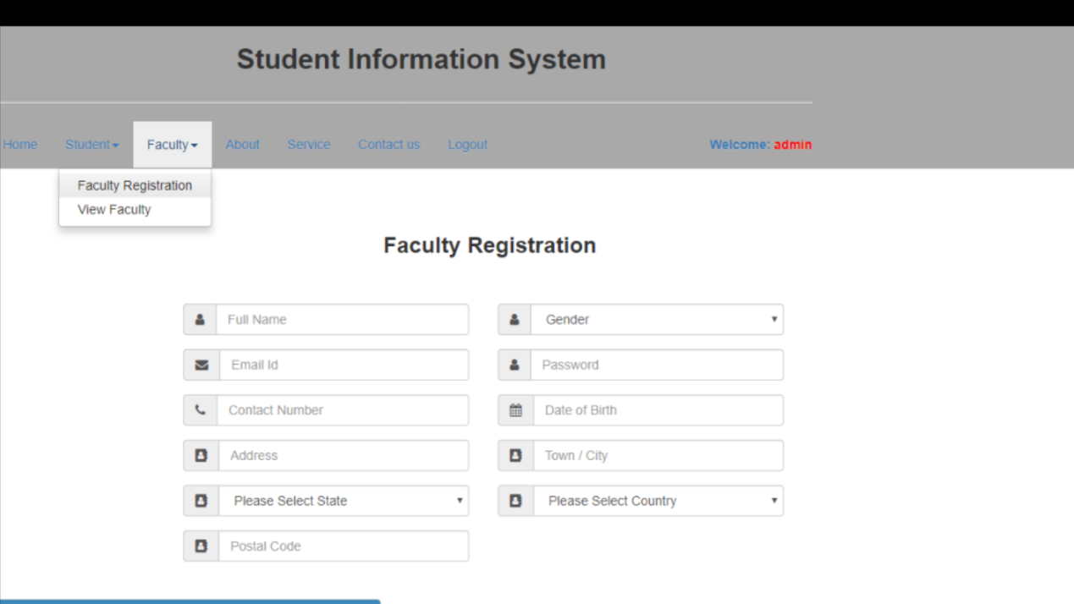

**16) Faculty login page**

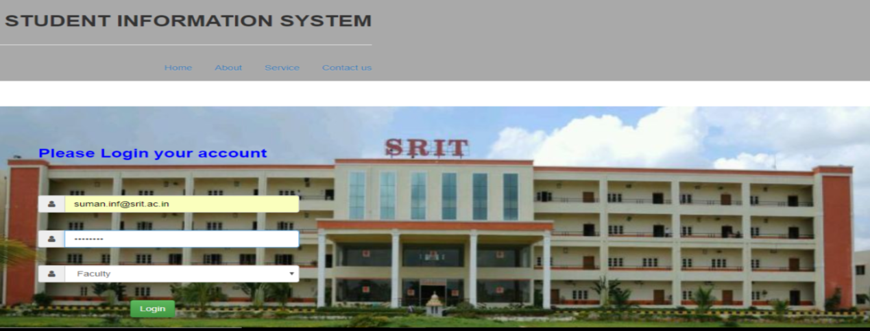

**17) Faculty home page**

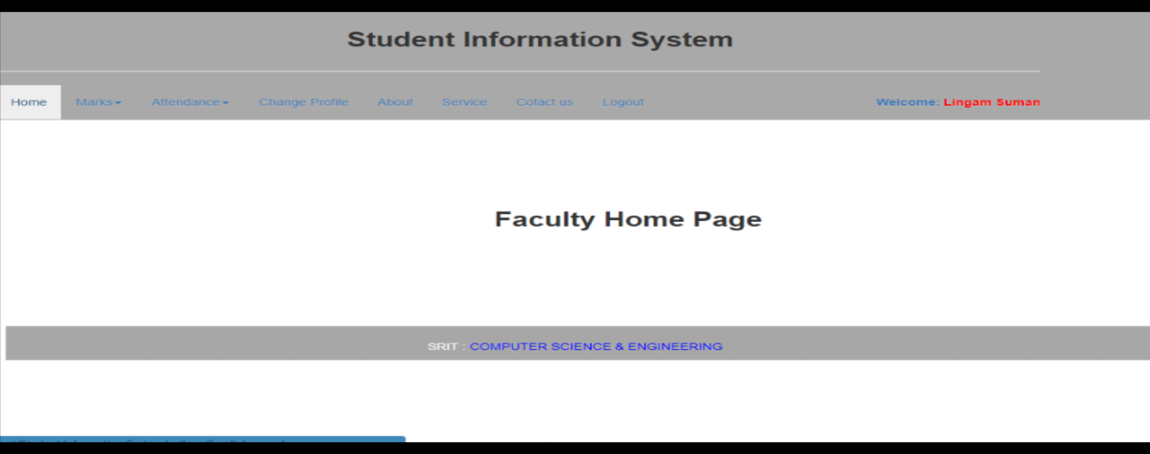

**18) Add student marks**

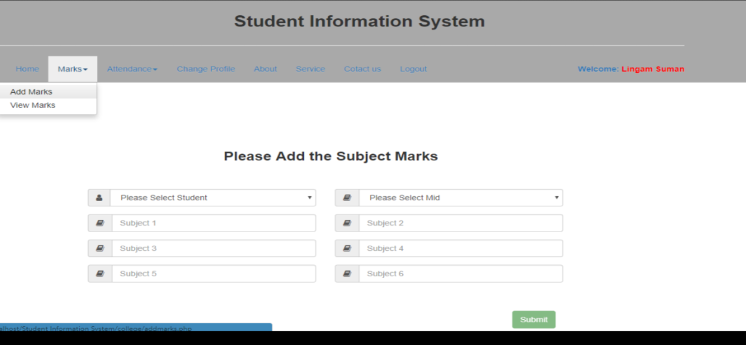

**19) Viewing students marks**

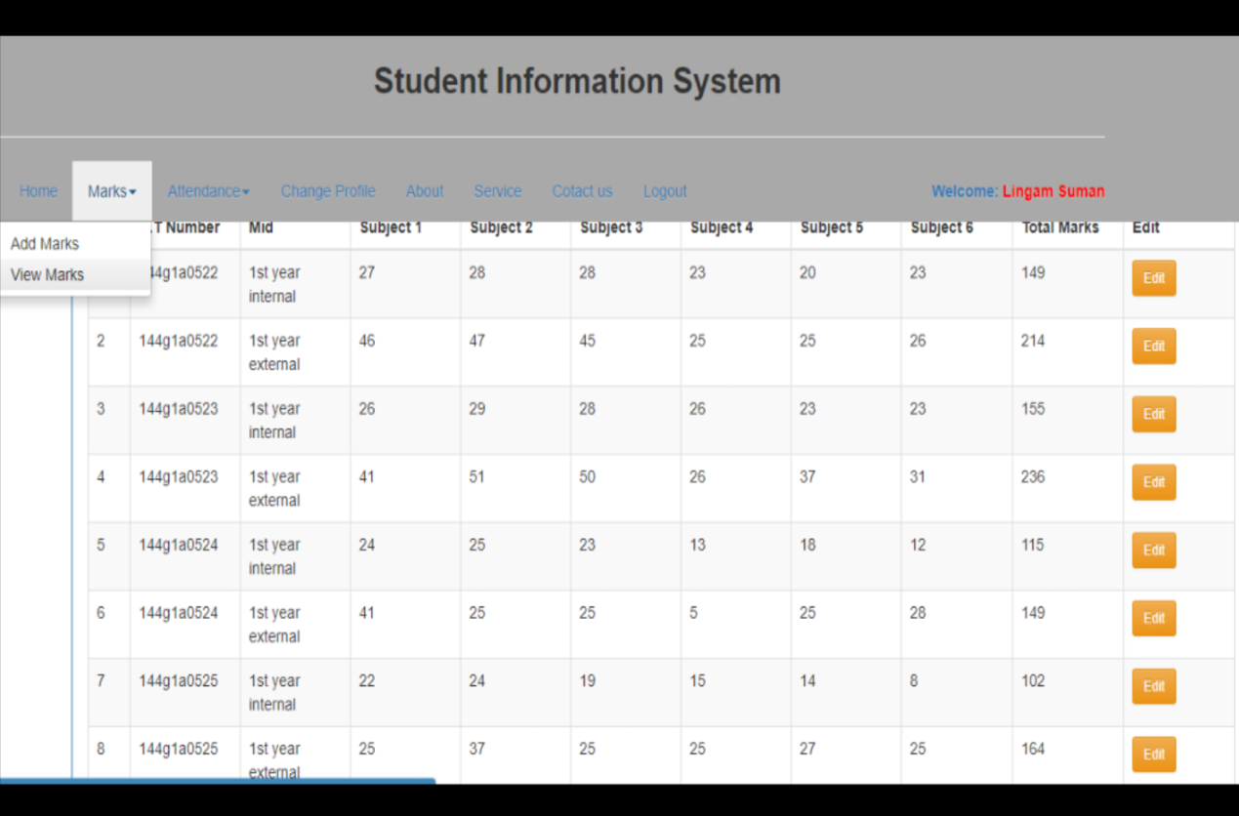

**20) Add students attendance**

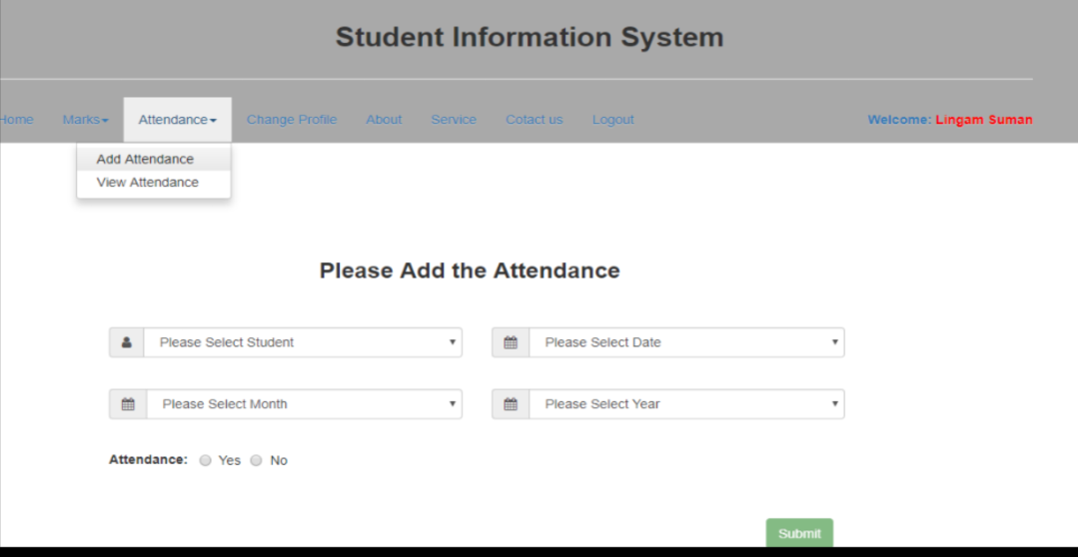

**21) Viewing students attendance**

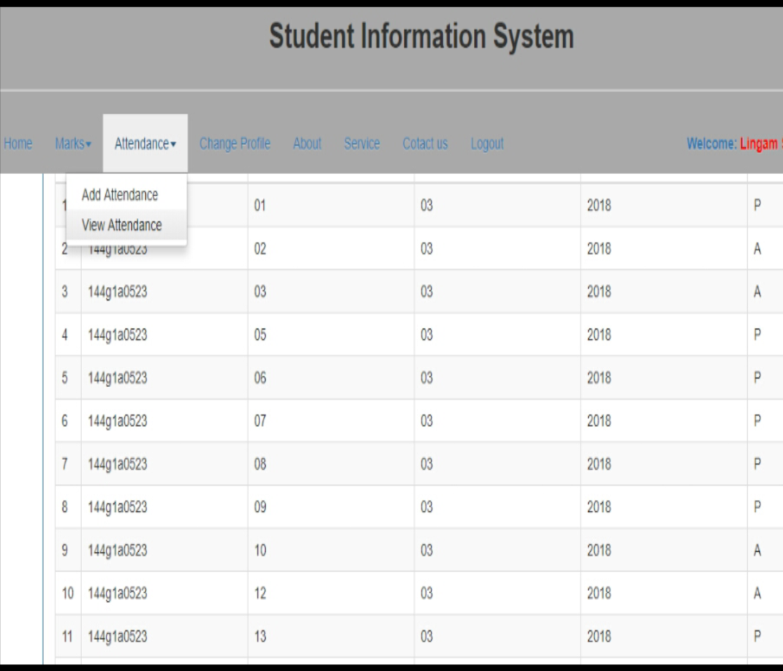

**22) Changing profile page for faculty**

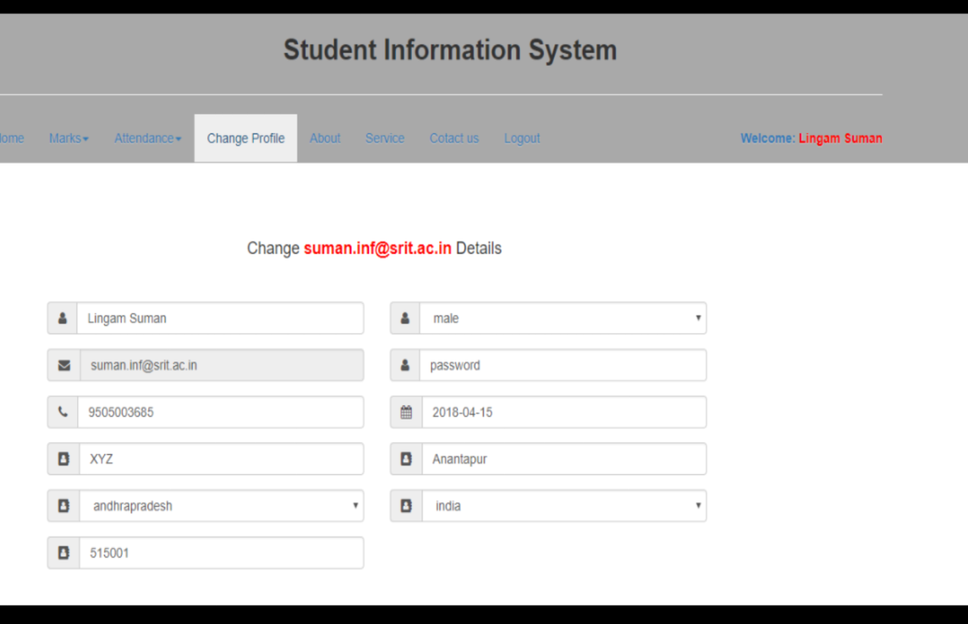

**23) Parent login page**

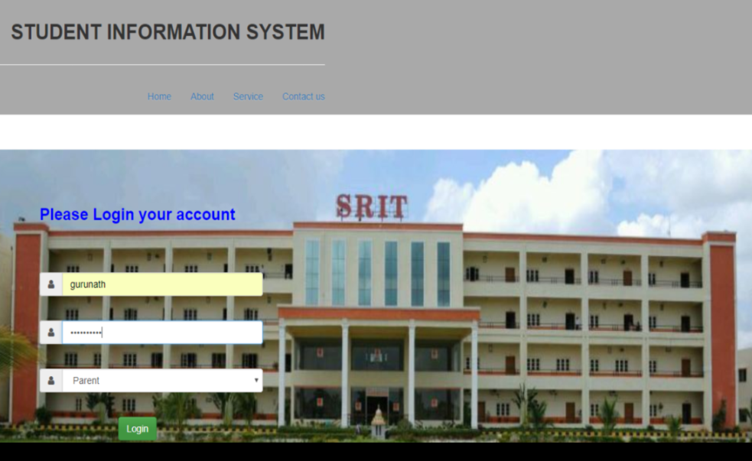

**24) Parent home page**

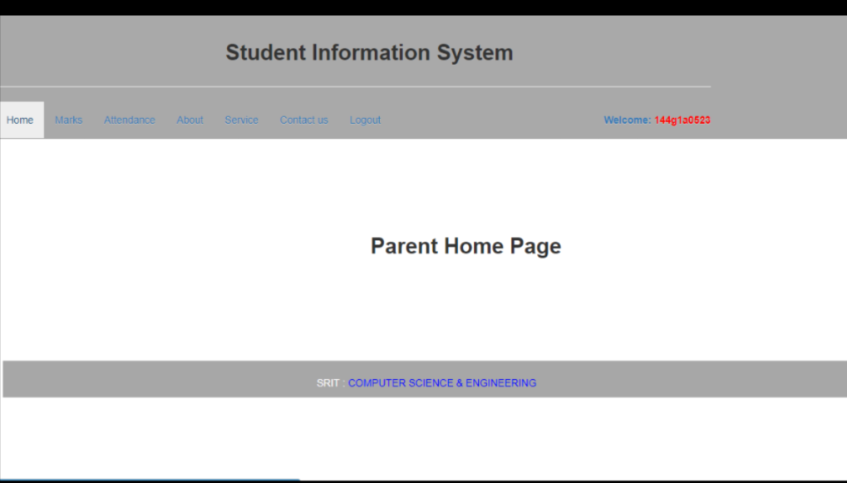

**25) Viewing students marks for parent**

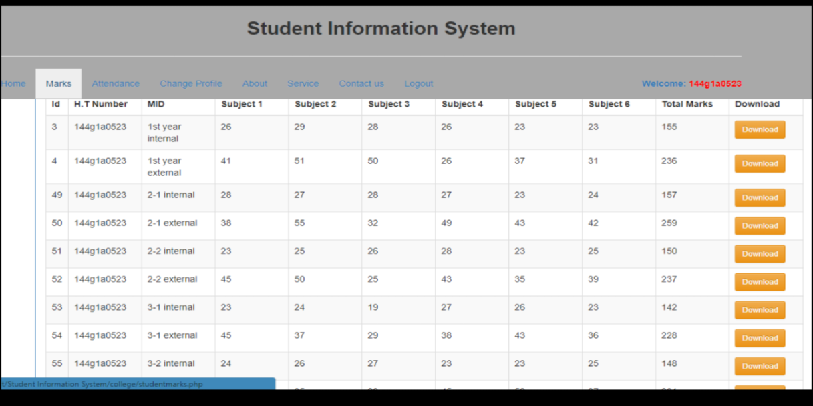

**26) Viewing students attendance for parent**

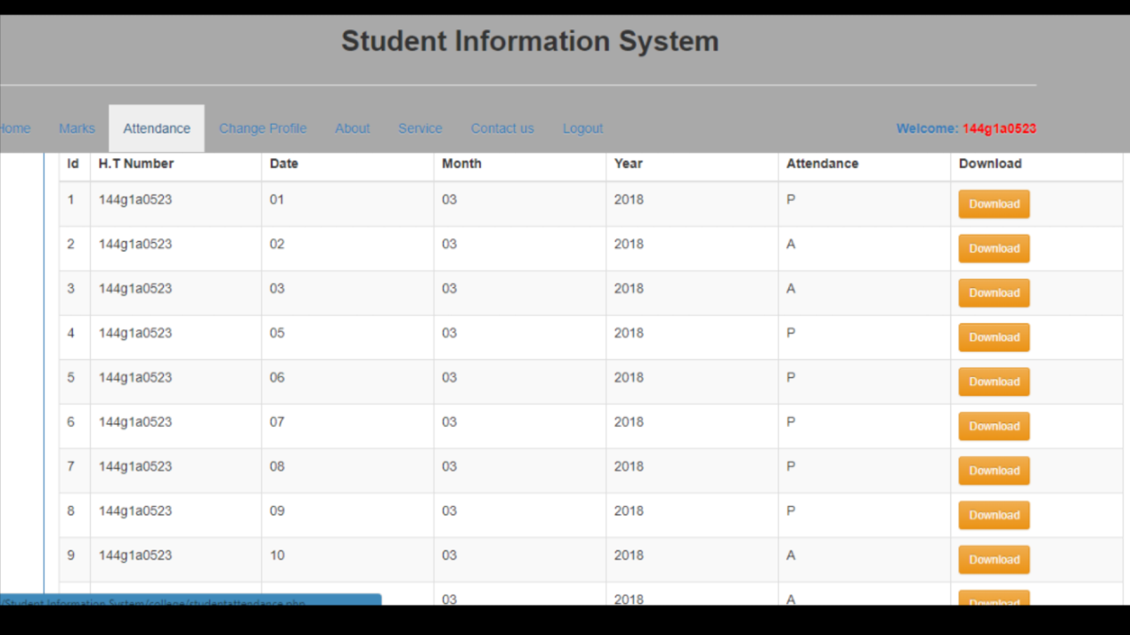

**27) Changing profile page for parent**

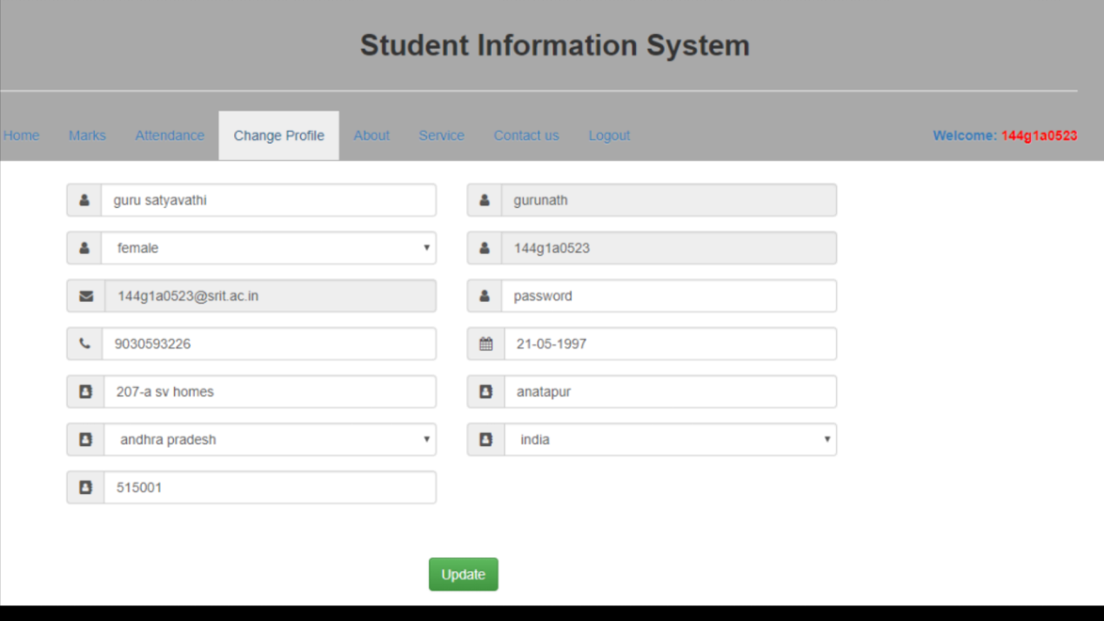

**5.4 Conclusion**

The above web pages are developed using Hyper Text Preprocessor(PHP), Hyper Text Markup Language(HTML), cascading styles and Structured query language.

**Chapter-6**

**Testing and Validation**

**6.1 Introduction**

Testing is an investigation conducted to provide stakeholders with information about the quality of the product or service under test.Software testing also provides an objective, independent view of the software to allow the business to appreciate and understand the risks of software implementation. Test techniques include, but are not limited to, the process of executing a program or application with the intent of finding software bugs.

**6.2 Methodology used for Testing**

The completion of a system will be achieved only after it has been thoroughly tested. Though this gives a feel the project is completed, there cannot be any project without going through this stage. Hence in this stage it is decided whether the project can undergo the real time environment execution without any break downs, therefore a package can be rejected even at this stage.

**Testing methods**

Software testing methods are traditionally divided into black box testing and white box testing. These two approaches are used to describe the point of view that a test engineer takes when designing test cases.

1. **Black box testing** - Black box testing treats the software as a "black box," without any knowledge of internal implementation. Black box testing methods include: equivalence partitioning, boundary value analysis, all-pairs testing, fuzz testing, model-based testing, traceability matrix, exploratory testing and specification-based testing.
2. **White box testing** - White box testing, by contrast to black box testing, is when the tester has access to the internal data structures and algorithms (and the code that implement these).White box testing methods can also be used to evaluate the completeness of a test suite that was created with black box testing methods. This allows the software team to examine parts of a system that are rarely tested and ensures that the most important function points have been tested.
3. **Grey Box Testing** - Grey box testing involves having access to internal data structures and algorithms for purposes of designing the test cases, but testing at the user, or black-box level. Manipulating input data and formatting output do not qualify as "grey box," because the input and output are clearly outside of the "black-box" that we are calling the system under test. This distinction is particularly important when conducting integration testing between two modules of code written by two different developers, where only the interfaces are exposed for test. Grey box testing may also include reverse engineering to determine, for instance, boundary values or error messages.

### Acceptance testing - Acceptance testing can mean one of two things:

1. A smoke test is used as an acceptance test prior to introducing a build to the main testing process.
2. Acceptance testing performed by the customer is known as user acceptance testing (UAT).

### Regression Testing - Regression testing is any type of **software testing** that seeks to uncover software regressions. Such regression occurs whenever software functionality that was previously working correctly stops working as intended. Typically regressions occur as an unintended consequence of program changes. Common methods of regression testing include re-running previously run tests and checking whether previously fixed faults have re-emerged.

### Non Functional Software Testing - Special methods exist to test non-functional aspects of software.

* Performance testing checks to see if the software can handle large quantities of data or users. This is generally referred to as software scalability. This activity of Non Functional Software Testing is often times referred to as Load Testing.
* Stability testing checks to see if the software can continuously function well in or above an acceptable period. This activity of Non Functional Software Testing is often times referred to as indurations test.
* Usability testing is needed to check if the user interface is easy to use and understand.
* Security testing is essential for software which processes confidential data and to prevent system intrusion by hackers.
* Internationalization and localization is needed to test these aspects of software, for which a pseudo localization method can be used.

Software Testing Strategies

A software testing strategy provides a road map for the software developer. Testing is a set of activities that can be planned in advance and conducted systematically. For this reason a template for software testing a set of steps into which we can place specific test case design methods should be defined for software engineering process. Any software testing strategy should have the following characteristics:

1. Testing begins at the module level and works “outward” toward the integration of the entire computer based system.
2. Different testing techniques are appropriate at different points in time.
3. The developer of the software and an independent test group conducts testing.
4. Testing and Debugging are different activities but debugging must be accommodated in any testing strategy.

**Unit Testing**

Unit testing focuses verification efforts in smallest unit of software design (module).

1. Unit test considerations
2. Unit test procedures

Integration Testing

Integration testing is a systematic technique for constructing the program structure while conducting tests to uncover errors associated with interfacing. There are two types of integration testing:

1. Top-Down Integration: Top down integration is an incremental approach to construction of program structures. Modules are integrated by moving down wards throw the control hierarchy beginning with the main control module.
2. Bottom-Up Integration: Bottom up integration as its name implies, begins construction and testing with automatic modules.
3. Regression Testing: In this contest of an integration test strategy, regression testing is the re execution of some subset of test that have already been conducted to ensure that changes have not propagate unintended side effects.

6.3 Validation

At the culmination of integration testing, software is completely assembled as a package; interfacing errors have been uncovered and corrected, and a final series of software tests – validation testing may begin. Validation can be fined in many ways, but a simple definition is that validation succeeds when software functions in a manner that can be reasonably expected by the customer.

Reasonable expectation is defined in the software requirement specification – a document that describes all user-visible attributes of the software. The specification contains a section titled “Validation Criteria”. Information contained in that section forms the basis for a validation testing approach.

**6.4 Conclusion**

This software has been computed successfully and was also tested successfully by taking “test cases”. It is user friendly, and has required options, which can be utilized by the user to perform the desired operations. Application software meets the information requirements specified to a great extent. The system has been designed keeping in view the present and future requirements in mind and made very flexible. The goals that are achieved by the software are instant access, improved productivity, Optimum utilization of resources, and efficient management of records.

**Conclusion**

It is always prudent to opt for a student information system that is designed using modern system architecture to cope with changing requirements. This system should encompass very solid information coding and distinctly outlined business applications, separating the presentation of details and methods of support.

Teachers can manage their counselling records using SIS. So that paperwork can be eliminated. Students as well as parents can track grades effortlessly. Thus the project is the user friendly approach.

**References**

**Articles:**

[1] Zhibing Liu, H. W., Hui Zan, Design and implementation of student information management system. International symposium on intelligence information processing and trusted computing, 2010

[2] Esmael Seid Ali. Alkan University College Student Information Management System. *American Journal of Operations Management and Information Systems*. Vol. 1, No. 1, 2016, pp. 1-6. doi: 10.11648/j.ajomis.20160101.11

[3] Xiaosheng Yu, Cai, Yi IEEE conference on designing and implementation of website based on PHP and MySQL. Published in E-Product and E-service, 2010 international conference

**Websites:**

[1] https://www.techlearning.com/news/student-information-systems/

[2] <https://www.w3schools.com/php/>

[3] <https://www.w3schools.com/mysql/>

[4] <https://www.apachefriends.org/>